Student name: MBEMDIA SALIOU Mohamed Mahzou Tariq
Matricule :
Course code : 6114
Teacher's name(Dr Fosso)

Project : Design, engineering, and securing of a full software and cloud infrastructure for a nationwide smart tourism platform (NaTourCam).

Project presentation
In the era of digital transformation, Cameroon, often described as “Africa in miniature,” faces the challenge of modernizing its tourism sector. The NaTourCam project was born out of a desire to create an integrated national platform capable of digitizing, promoting, and securing the country's exceptional cultural and natural heritage.
Unlike traditional information systems, NaTourCam is designed as a complex socio-technical system. It must serve a massive user base of 7 million people while respecting cultural diversity represented by more than 250 national languages. The infrastructure is based on strategic geographic distribution across the country's 10 regions, requiring high-precision software engineering to guarantee performance and data sovereignty.

Part 1 : DDD and Agile Architecture

Bounded Contexts
The decomposition of NaTourCam into bounded contexts follows Domain-Driven Design principles, ensuring that each domain encapsulates a coherent business responsibility, aligns technical models with cultural realities, and enables independent evolution of services.

Context | Liability | Key entities
Cultural Heritage | - Management of cultural content (stories, rituals, languages, objects)  - Approval by cultural authorities | - CulturalArtifact  - Language  - Translation  - CulturalAuthority
Tourism Sites Context | - Management of tourist sites (parks, museums, chiefdoms)  - Geographic and logistical information | - TourismSite  - SiteCategory  - OpeningSchedule  - Region
User Profiles Context | - User management (tourists, partners, administrators)Préférences linguistiques et culturelles | - User  - Role  - Preference  - AccessibilitySettings
Ticketing & Payments Context | - Ticket sales  - Integration of mobile payments (Mobile Money) | - Ticket  - PaymentTransaction  - PaymentProvider  - Invoice
Recommendation Engine Context | - Personalized suggestions  - User behavior analysis | - RecommendationModel  - UserBehavior  - ScoringRule
Geo-Services Context | - Geolocation  - Itineraries  - Security alerts | - GeoLocation  - Itinerary  - SafetyAlert
Partner Integration Context | - APIs for hotels, agencies, and transport companies  - Integration contract management | - Partner  - PartnerAPIKey  - Contract
Analytics & Governance Context | - Dashboards  - Statistics for the Department of Tourism | - KPI  - Report  - DataAggregation

Ubiquitous Language
The Ubiquitous Language establishes a shared vocabulary between developers, cultural experts, tourism operators, and government stakeholders, reducing ambiguity and ensuring semantic consistency across the system.

Contexts | Terms | Job Definition
Cultural Heritage | Cultural Artifact | Validated cultural element representing local identity
Cultural Heritage | Cultural Authority | Institution or chiefdom authorizing dissemination
Cultural Heritage | Translation | Official language version of content
Cultural Heritage | Sacred Content | Restricted access content
Ticketing & Payments Context | Ticket | Digital right of access to a website
Ticketing & Payments Context | Payment Transaction | Traceable financial transaction
Ticketing & Payments Context | Mobile Payment | Payment via Mobile Money
Ticketing & Payments Context | Refund | refund check
Geo-Services | Itinerary | Recommended geolocated route
Geo-Services | Safety Alert | Real-time risk notification
Geo-Services | Geo-Fence | Virtual zone triggering an alert

Choix de la Méthodologie Agile : SCRUM
The Scrum framework is selected as the primary Agile methodology for the NaTourCam project due to its adaptability, strong stakeholder engagement mechanisms, and suitability for large-scale, distributed systems.

- Scalability : Scrum allows the use of the “Scrum of Scrums” framework to coordinate teams distributed between Yaoundé, Buea, Douala, and Maroua..
- Uncertainty :Short cycles (Sprints) allow for rapid testing of user acceptance of VR/AR services.
- Stakeholder Diversity : Sprint Reviews provide a structured framework for incorporating feedback from cultural guardians, government, and tourism agencies.
- Incremental Delivery : Allows you to launch basic services (ticketing) first before adding complex modules such as the recommendation engine.

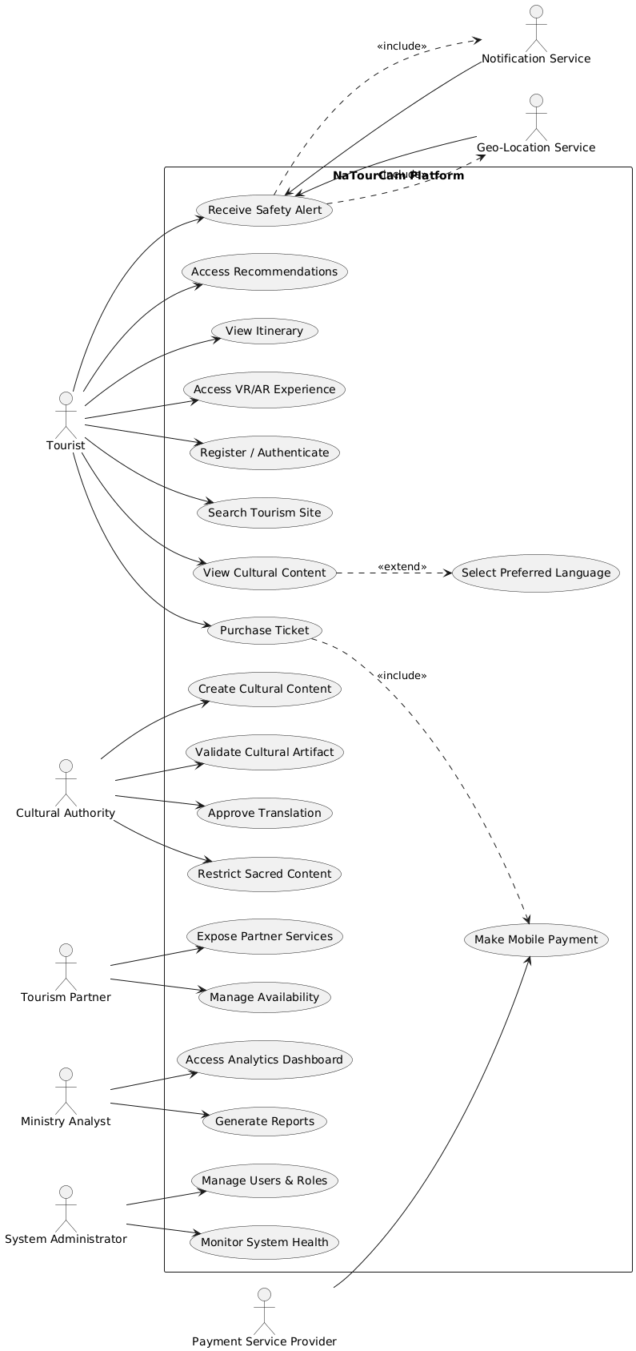
Major Interactions

Contribution of Agility to Collaboration
The implementation of Scrum for NaTourCam is not only about coding faster, but also about building bridges between very different worlds (technology, tradition, administration). According to Sommerville, the success of a complex system depends on the involvement of stakeholders throughout the process.

With Linguists and Cultural Guardians
- Sprints Reviews & Démos : At the end of each sprint (2 to 4 weeks), we present the translation prototypes or 3D models to the heritage guardians. This allows them to immediately validate whether the representation of a sacred artifact or local language (e.g., Ewondo, Duala, Fufulde) is accurate and respectful.
- Product Backlog Refinement : Linguists help refine user stories to ensure that cultural nuances are incorporated from the design phase onwards, thereby avoiding costly errors at the end of the project.

With Local Tour Operators
- Incremental Delivery : Instead of waiting two years, tourism agencies receive functional modules quickly (e.g., the booking module). This allows them to adjust their commercial offerings based on the features actually available on the platform.
- Feedback Loops : Local guides test the beta versions in the field (in national parks) and report any connectivity or usability issues directly to the development team.

With Government Agencies (Regulation)
- Transparency and Visibility :The Product Owner (often a representative of the Ministry) has a clear view of progress via the Information Radiator (Kanban/Scrum Board). This facilitates accountability and alignment with national digitization policies.
- Adaptability to legislative changes: If the government changes a law on data protection or tourist taxes, agility allows this change to be incorporated into the next Sprint without disrupting the entire project.

Among Developers (Technique)
- Daily Scrums : Technical teams distributed across 10 regions synchronize daily. This reduces silos and ensures that developers in Maroua work to the same standards as those in Douala.

In a project like NaTourCam, a rigid approach (Waterfall) would be a failure because cultural needs are too nuanced to be set out in a 500-page document at the start of the project. Agility allows for co-construction of the system: the technology adapts to Cameroonian culture, not the other way around.

Partie 2 : SOFTWARE ARCHITECTURE and MICROSERVICES

A. Microservices Architecture

Decomposition into microservices
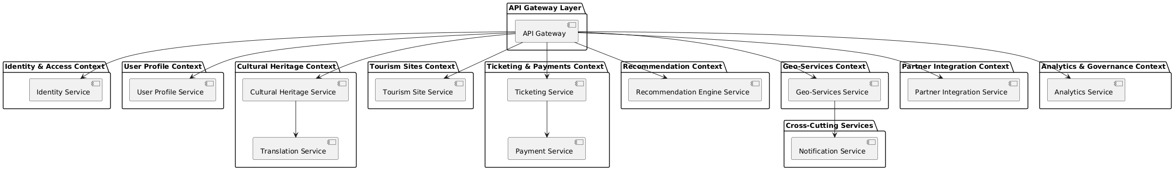
Image 1 : decomposition into microservices

Component diagram
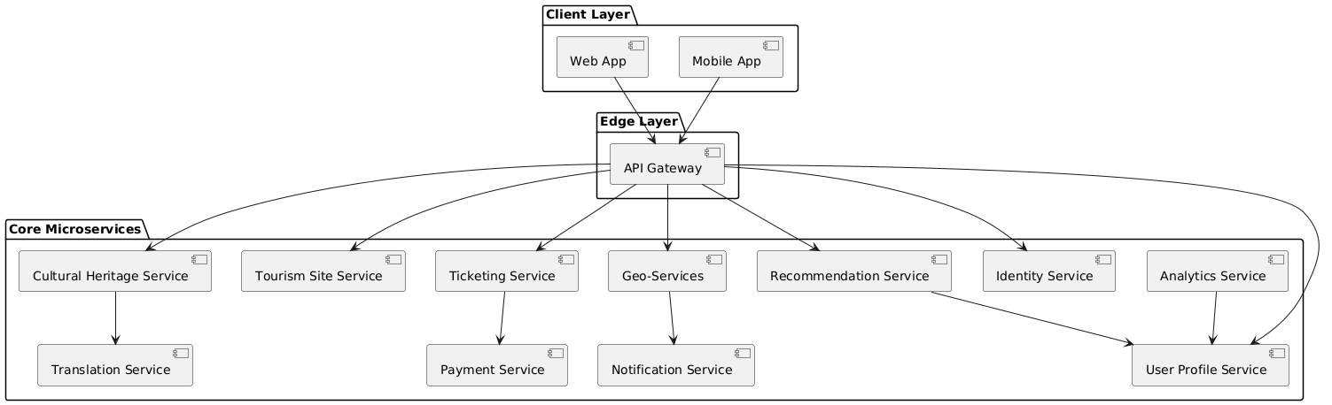
Image 2 : component diagram

This component diagram illustrates a cloud-native microservices architecture where each service encapsulates a specific business capability and communicates through well-defined APIs via an API Gateway.

Support for multilingualism and cultural diversity
Approche architecturale

- Strict separation:

- Cultural Heritage Service -> source content
- Translation Service -> language versions

- Each piece of content is associated with:
- a language
- a validation status
- a cultural authority

- Automatic fallback :
- Local language → French/English
Key advantage :
- No data duplication
- Compliance with cultural norms

Role of the API Gateway and Service Mesh
API Gateway:
- Centralized authentication
- Traffic limitationAgrégation de réponses
- Protection against DDoS attacks
Service Mesh :
- Internal TLS encryption
- Circuit breaking
- Observability (metrics, traces)
- Detailed management of security policies

Data Management and APIs

Distributed data architecture (SQL + NoSQL)
Fundamental principle: Polyglot Persistence — each microservice chooses the database that best suits its needs.
Proposed architecture
Micorservice | Type de DB | Justification
User, Ticketing, Payment | PostgreSQL (SQL) | ACID Transactions
Cultural Content | MongoDB (NoSQL) | Semi-structured data
Geo-Services | PostGis | Spatial queries
Recommendation Engine | NoSQL / Vector DB | Quick scoring
Analytics | Data Warehouse | Massive aggregation
Cache | Redis | Performance

OpenAPI — APIs critiques

Tourism Site Search API (extrait)
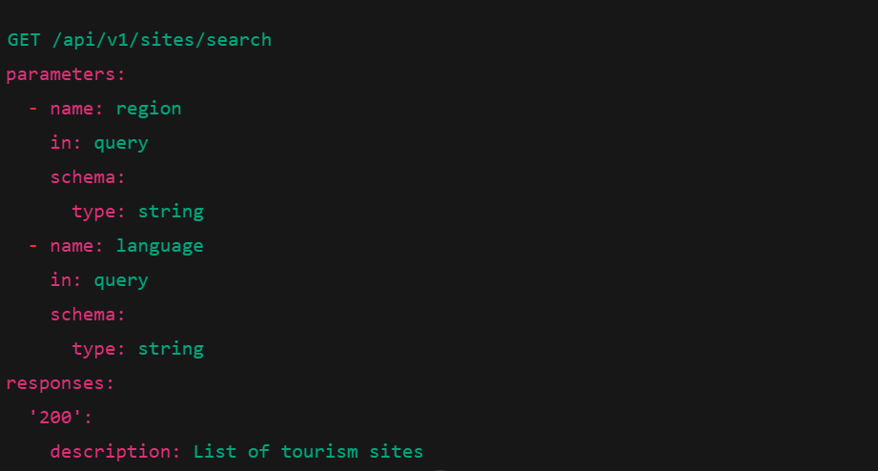

Cultural Content API (extrait)
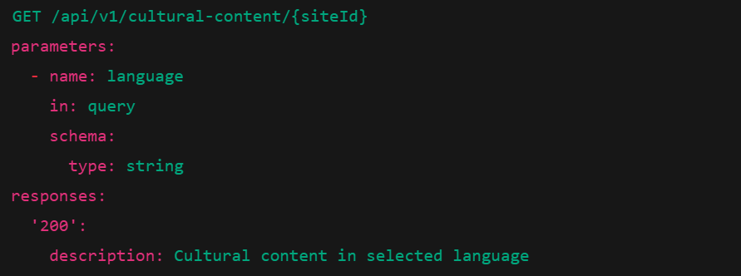

Performance and Scalability

Scalabilité et performance
- Horizontal vs Vertical Scaling
- Horizontal : adding pods
- Vertical : increase in resources (limited)
- Caching Strategies
- Redis : sessions, profils
- CDN : images, videos, AR/VR contents
- HTTP Cache Headers
- Management of 500,000 simultaneous visitors
- Auto-scaling Kubernetes
- Load Balancers multi-régions
- CDN mondial
- Architecture event-driven
- Graceful degradation
The system prioritizes availability and user experience through elastic scaling and intelligent caching.

PART III : CI/CD, DEVOPS and SOFTWARE QUALITY

Conception du pipeline CI/CD complet

